WhatNext Vision Motors: Shaping the Future of Mobility with Innovation and Excellence

User Story:
WhatsNext Vision Motors is revolutionizing its customer experience and operational efficiency with a cutting-edge Salesforce CRM implementation. The project streamlines the vehicle ordering process by auto-assigning orders to the nearest dealer based on customer location and preventing orders for out-of-stock vehicles. Automated workflows update order statuses dynamically and send scheduled email reminders for test drives. Key technical implementations include Apex triggers for stock validation, batch jobs for stock updates, and scheduled Apex for automated order processing. This initiative enhances customer satisfaction, improves order accuracy, and boosts overall operational efficiency.

INTRODUCTION

Project Overview :

WhatNext Vision Motors implemented a Salesforce-based CRM solution to modernize vehicle ordering and dealership operations. The system automates vehicle order placement, validates stock availability, assigns orders to the nearest dealer, schedules test drive reminders, and updates order statuses dynamically. This transformation replaces manual and disconnected processes with a centralized, automated platform, improving operational efficiency and customer satisfaction.

Purpose :

The purpose of this project is to automate vehicle ordering, stock management, dealer assignment, and customer engagement using Salesforce CRM. The system aims to reduce manual intervention, eliminate order errors, provide real-time tracking, and enhance overall business productivity while delivering a seamless customer experience.

IDEATION PHASE

Problem Statement (Customer Problem Statement Template)
PS | I am (Customer) | I’m trying to | But | Because | Which makes me feel
PS-1 | Operations Manager | manage vehicle orders | stock info is manual | systems are disconnec te d | stressed
PS-2 | Customer | place vehicle orders | availabili ty unclear | delayed updates | uncertain

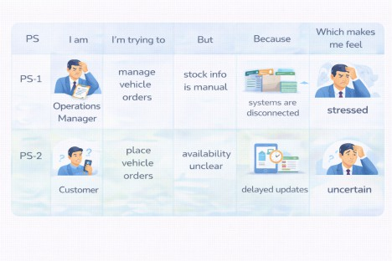

Empathy Map Canvas
User Persona: Operations Manager
    - Think & Feel: Concerned about wrong orders & stock errors

    - Hear: Dealer and customer complaints
    - See: Registers & spreadsheets
    - Say & Do: Manual follow-ups
    - Pain: Delays & cancellations
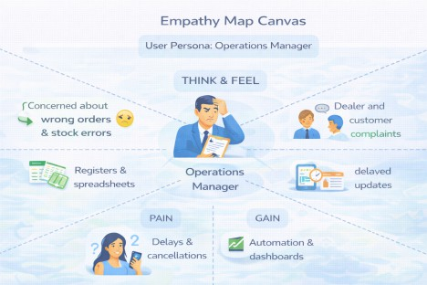
    - Gain: Automation & dashboards

Brainstorming & Idea Prioritization
Ideas Considered
    - Manual registers
    - Spreadsheet tracking
    - Standalone portal
    - Salesforce CRM

Final Selection

Salesforce CRM selected due to:
    - Automation
    - Scalability
    - Real-time visibility

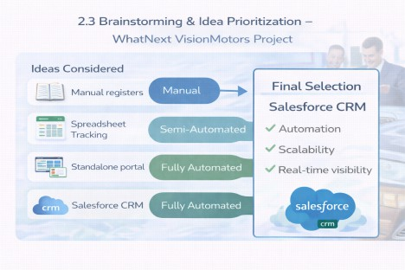

REQUIREMENT ANALYSIS PHASE

Customer Journey Map
Stages:
    - Inquiry → Vehicle Selection → Order Placement → Dealer Assignment → Stock Validation → Test Drive → Confirmation → Reporting

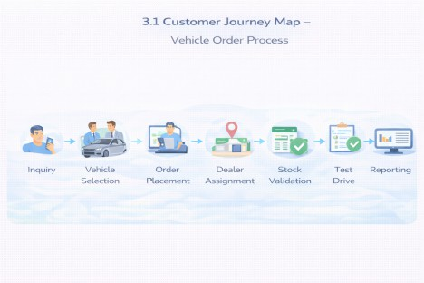

Solution Requirements
Functional Requirements
FR No | Requirement
FR-1 | Vehicle management
FR-2 | Dealer management
FR-3 | Customer order creation
FR-4 | Stock validation
FR-5 | Dealer auto-assignment

FR-6 | Test drive scheduling
FR-7 | Reports & dashboards

Non-Functional Requirements
NFR | Description

Usability | Lightning UI for easy navigation
Security | Role-based access control
Reliability | Accurate automation
Performance | Fast order processing
Availability | 24/7 cloud access
Scalability | Multi-dealer support

Data Flow Diagram
Flow:
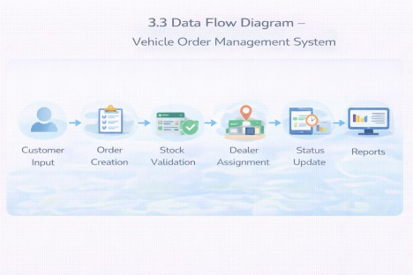
Customer Input → Order Creation → Stock Validation → Dealer Assignment → Status Update → Reports

Technology Stack
Layer | Technology
UI | Salesforce Lightning
Logic | Salesforce Flows

Database | Salesforce Objects
Automation | Validation Rules, Triggers
Processing | Batch Apex, Scheduled Apex
Reporting | Reports & Dashboards

PROJECT DESIGN PHASE

Problem–Solution Fit
The system eliminates fragmented operations by integrating automated stock validation, dealer assignment, and order processing within Salesforce.
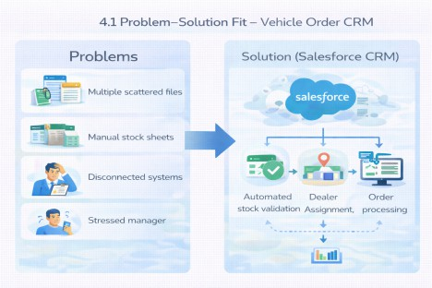

Proposed Solution
Functional Requirements
Parameter | Description

Problem | Manual vehicle ordering
Solution | Salesforce CRM
Innovation | Automated dealer assignment
Impact | Faster service
Business Model | Dealer network
Scalability | Multi-location support

Solution Architecture
Components:
    - Vehicle Object
    - Dealer Object
    - Customer Object
    - Order Object
    - Test Drive Object
    - Service Request Object
    - Flows
    - Apex Triggers
    - Batch Jobs
    - Reports
    - Dashboards

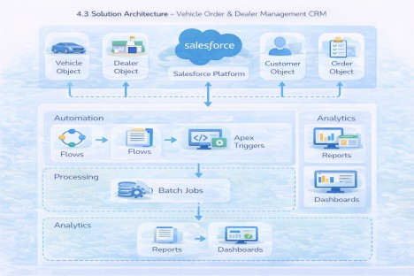

PROJECT PLANNING & SCHEDULING

Project Planning
    - Agile methodology
    - Epics → Stories → Story Points
    - Sprint-based execution
    - Velocity calculation used for estimation
Product Backlog, Sprint Schedule, and Estimation (4 Marks)

Sprint | Functional Requirement (Epic) | User Story Number | User Story / Task | Story Points | Priority | Team Members
Sprint-1 | Developer Setup | USN-1 | As a system administrator, I want to create and configure a Salesforce developer account so that I can build and deploy the vehicle order management system. | 3 | High | Member1
Sprint-2 | Data Modeling | USN-2 | As an admin, I want to create Vehicle, Dealer, Customer, Order, and Service Request objects with proper relationships so that all business data is stored and managed systematically. | 5 | High | Member2

Sprint | Functional Requirement (Epic) | User Story Number | User Story / Task | Story Points | Priority | Team Members
Sprint-2 | Data Modeling | USN-3 | As a staff member, I want dedicated tabs and a Lightning App for all modules so that I can easily navigate and manage vehicle orders and dealer operations. | 5 | High | Member3
Sprint-3 | Automation | USN-4 | As a system, I want to validate stock availability, mandatory fields, and order inputs so that invalid or incomplete vehicle orders are prevented. | 3 | High | Member4
Sprint-3 | Automation | USN-5 | As a sales coordinator, I want automated flows to assign the nearest dealer and update order status so that processing becomes faster and requires minimal manual effort. | 3 | High | Member4
Sprint-4 | Apex | USN-6 | As a system, I want Apex triggers to automatically perform actions such as order confirmation and dealer assignment so that critical processes occur instantly and accurately. | 5 | High | Member1
Sprint-4 | Apex | USN-7 | As an inventory manager, I want batch jobs to update vehicle stock levels automatically so that inventory data remains accurate and up to date. | 5 | High | Member2
Sprint-5 | Reports | USN-8 | As a manager, I want reports showing order status, dealer performance, and sales metrics so that I can monitor operations and make informed decisions. | 4 | High | Member3
Sprint-6 | Dashboards | USN-9 | As a manager, I want dashboards showing order status, dealer performance, and sales metrics so that I can monitor operations and make informed decisions. | 4 | Medium | Member4

Project Tracker, Velocity & Burndown Chart: (4 Marks)

Sprint | Total Story Points | Duration | Sprint Start Date | Sprint End Date (Planned) | Story Points Completed (as on Planned End Date) | Sprint Release Date (Actual)
Sprint-1 | 20 | 6 Days | 24 Oct 2022 | 29 Oct 2022 | 20 | 29 Oct 2022
Sprint-2 | 20 | 6 Days | 31 Oct 2022 | 05 Nov 2022
Sprint-3 | 20 | 6 Days | 07 Nov 2022 | 12 Nov 2022
Sprint-4 | 20 | 6 Days | 14 Nov 2022 | 19 Nov 2022

- Project Development Phase:

What you'll learn

- Data Modelling
- Fields and Relationships
- Lightning App Builder
- Record Triggered Flows
- Apex and Apex Triggers
- Batch Apex
- Scheduled Apex

Milestone 1: Salesforce Account

Activity 1: Creating Developer Account
Creating a developer org in salesforce.
- Go to https://developer.salesforce.com/signup
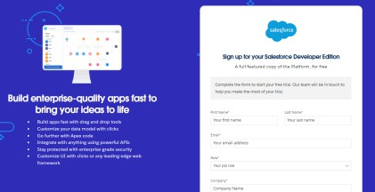
- On the sign up form, enter the following details :
  - First name & Last name
  - Email
  - Role : Developer
  - Company : College Name
  - County : India
  - Postal Code : pin code
  - Username : should be a combination of your name and company This need not be an actual email id, you can give anything in the format : username@organization.com
Click on sign me up after filling these.

Activity 2: Account Activation
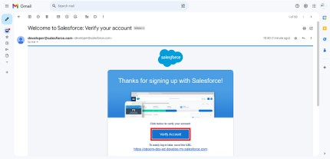
- Go to the inbox of the email that you used while signing up. Click on the verify account to activate your account. The email may take 5-10mins.
- Click on Verify Account
- Give a password and answer a security question and click on change password.

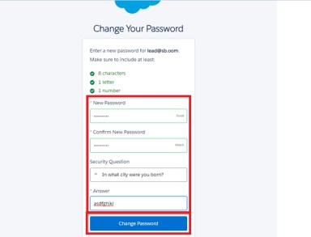
- Then
you will redirect to your salesforce setup page.

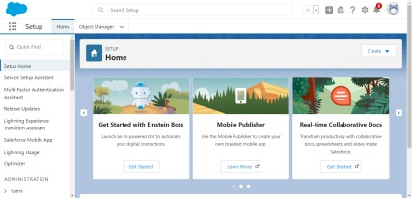

Milestone 2: Data Management-Objects

Objects & Relationships
Object Name | Purpose | Relationships
Vehicle c | Stores vehicle details | Related to Dealer & Orders
Vehicle_Dealer c | Stores authorized dealer info | Related to Orders
Vehicle_Customer_  _c  Vehicle_Order c | Stores customer details  Tracks vehicle purchases | Related to Orders & Test Drives  Related to Customer & Vehicle

Vehicle_Test_Drive c | Tracks test drive bookings | Related to Customer & Vehicle
Vehicle_Service_Requ es t c | Tracks vehicle servicing requests | Related to Customer & Vehicle

To Navigate to Setup page:

Click on gear icon → click setup.
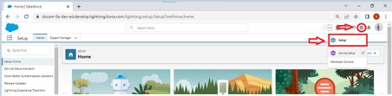

Activity 1: Create Vehicle Object
The purpose of creating a Vehicle custom object is to have a clear picture of the vehicle details.
To create an object:
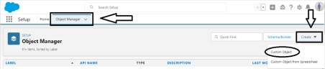
- From the setup page → Click on Object Manager → Click on Create → Click on Custom Object.
  - Enter the label name→ Vehicle
  - Plural label name→ Vehicles
  - Enter Record Name Label and Format
    - Record Name → Vehicle Name
    - Data Type → Text

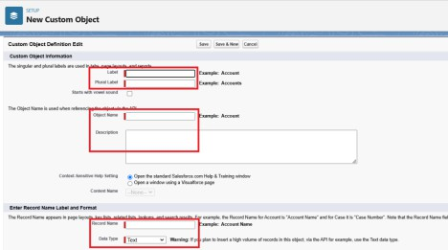
- Click on Allow reports,
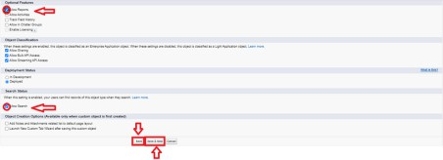
- Allow search → Save.

Activity 2: Create Dealer Object

The purpose of creating a Dealer object is to have detailed information about Dealer. To create an object:
- From the setup page → Click on Object Manager → Click on Create → Click on Custom Object.
  - Enter the label name→ Vehicle Dealer
  - Plural label name→ Vehicle Dealers
  - Enter Record Name Label and Format
    - Record Name → Dealer Name

    - Data Type → Text
- Click on Allow reports,
- Allow search → Save

Activity 3: Creating remaining objects

Creating remaining objects

Create remaining objects which have mentioned in the above table Data Management-Objects

Milestone 3: Data Management-Tabs

Activity 1: Creating a Custom Tab(Vehicle)

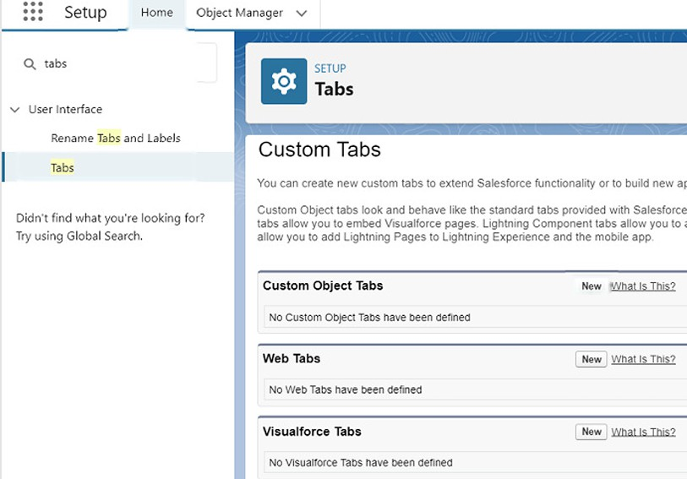

2. Select Object(Vehicle) -> Select any tab style -> Next (Add to profiles page) keep it as default -> Next (Add to Custom App) keep it as default -> Save.

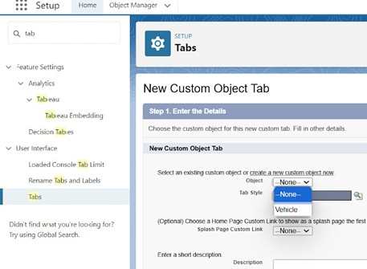

Activity 2:
Now create tabs for Other objects as well which we have created above Objects.

Milestone 4: Data Management-App Manager

Activity 1: Create a Lightning App To create a lightning app page:
- Go to setup page → search “app manager” in quick find → select “app manager” → click on New lightning App.
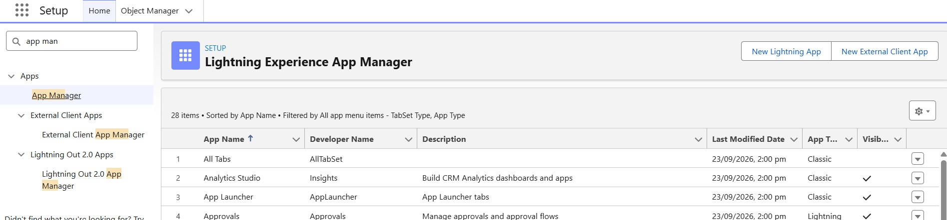
- Fill the app name in app details and branding as follow App Name : WhatNext Vision Motors
Developer Name : this will auto populated Description : Give a meaningful description
Image : optional (if you want to give any image you can otherwise not mandatory) Primary color hex value : keep this default
- Then click Next → (App option page) keep it as default → Next → (Utility Items) keep it as default → Next.

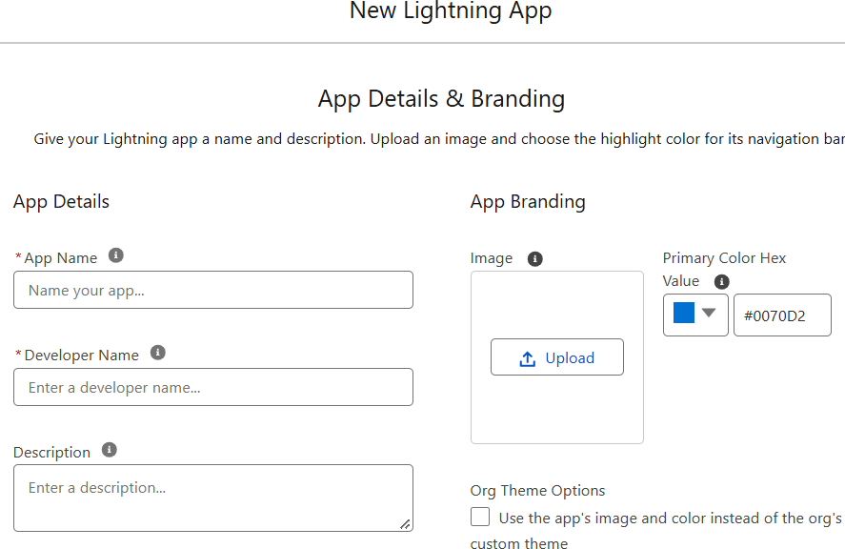
Add Navigation Items:
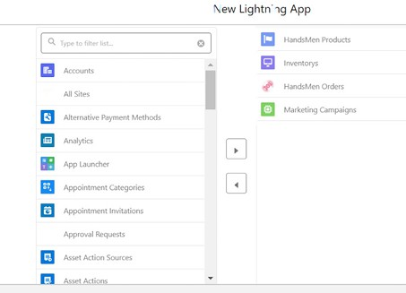
4.To Search the items in the search bar(Vehicle, Dealer, Customer, Order, Test Drive, Service Request, Reports, Dashboard) from the search bar and move it using the arrow button → Next.
Note: select the custom object which we have created in the previous activity.

- To Add User Profiles:
5.Search profiles (System administrator) in the search bar → click on the arrow button
6. save & finish.

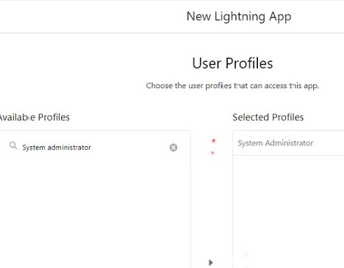
Search profiles (System administrator) in the search bar → click on the arrow button
→ save & finish.

Milestone 5: Data Management-Fields

Key Fields for Each Object

Vehicle c (Custom Object)
  - Vehicle_Name c (Text)
  - Vehicle_Model c (Picklist: Sedan, SUV, EV, etc.)
  - Stock_Quantity c (Number)
  - Price c (Currency)
  - Dealer c (Lookup to Dealer c)
  - Status c (Picklist: Available, Out of Stock, Discontinued)

- Vehicle_ Dealer c (Custom Object)
  - Dealer_Name c (Text)
  - Dealer_Location c (Text)
  - Dealer_Code c (Auto Number)
  - Phone c (Phone)
  - Email c (Email)

- Vehicle_Order c (Custom Object)
  - Customer c (Lookup to Customer c)

  - Vehicle c (Lookup to Vehicle c)
  - Order_Date c (Date)
  - Status c (Picklist: Pending, Confirmed, Delivered, Canceled)

- Vehicle_Customer c (Custom Object)
  - Customer_Name c (Text)
  - Email c (Email)
  - Phone c (Phone)
  - Address c (Text)
  - Preferred_Vehicle_Type c (Picklist: Sedan, SUV, EV, etc.)

- Vehicle_Test_Drive c (Custom Object)
  - Customer c (Lookup to Customer c)
  - Vehicle c (Lookup to Vehicle c)
  - Test_Drive_Date c (Date)
  - Status c (Picklist: Scheduled, Completed, Canceled)

- Vehicle_Service_Request c (Custom Object)
  - Customer c (Lookup to Customer c)
  - Vehicle c (Lookup to Vehicle c)
  - Service_Date c (Date)
  - Issue_Description c (Text)
  - Status c (Picklist: Requested, In Progress, Completed)

Object Field Creation :
- Go to setup → click on Object Manager → type object name(Vehicle) in quick find


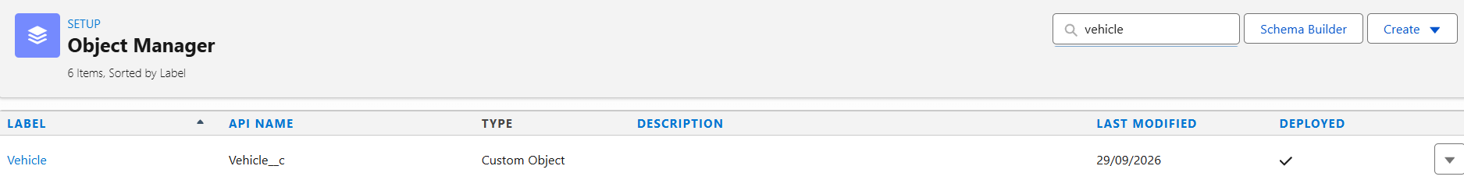

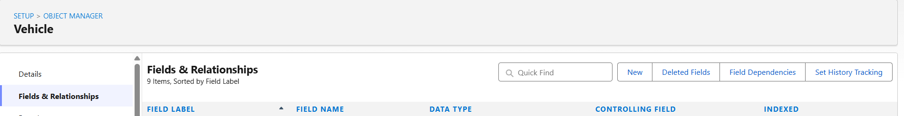
- Now click on ·Fields & Relationships· -> New

3. Select Data type as ·PickList·.

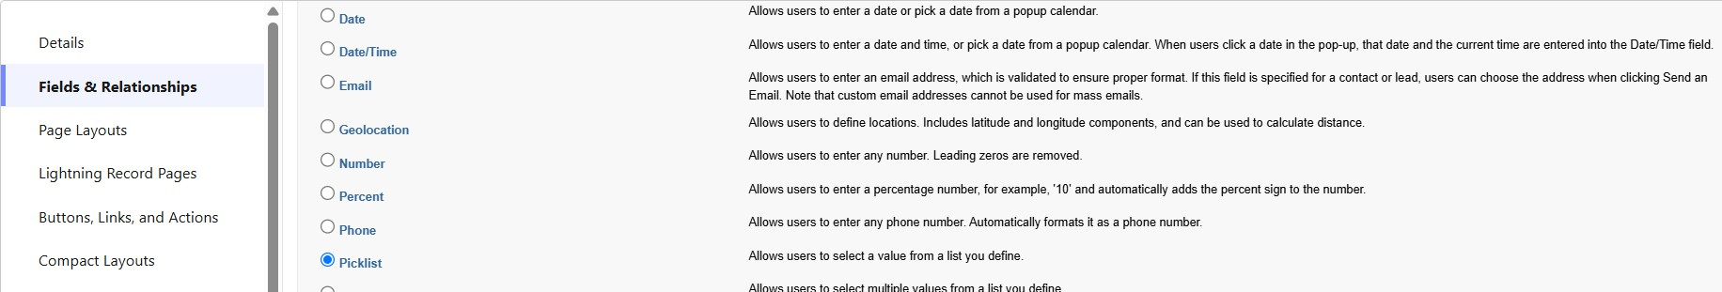

- Click on Next
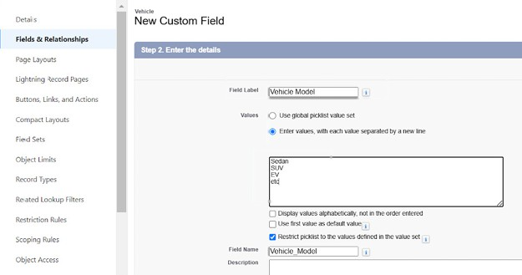
- Fill the above as following:
  - Field Label: Vehicle Modal
  - Fill PickList Values
  - Click on Next → Next → Save and new.

Object Field Creation-2 :
- Repeat the steps 1 & 2 from the activity 1
- Select Data type as “Number”.
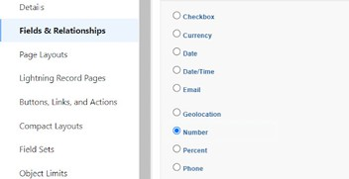

- Click on Next

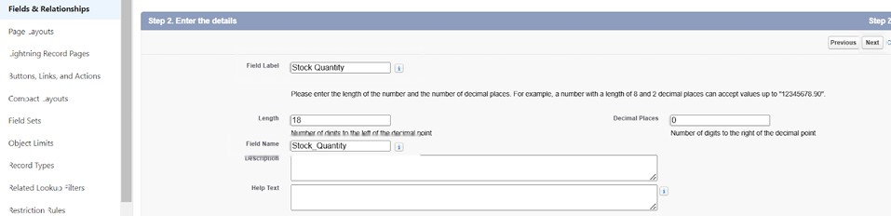

- Fill the above as following:
  - Field Label: Stock Quality
  - Click on Next → Next → Save and new.

Relationship Field Creation :

Creating a Lookup RelationShip in Vehicle Object to Dealer Object.
- Select DataType as Lookup Relationship.
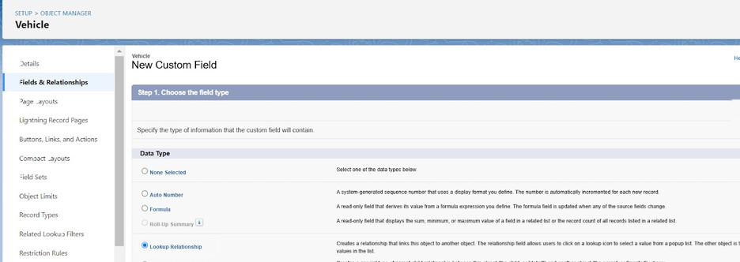
- Click Next
- Select Dealer Object Form Related Filed.
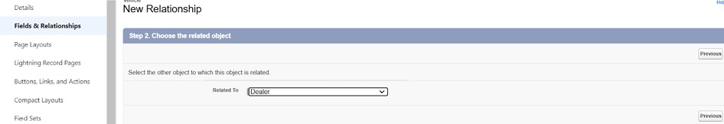

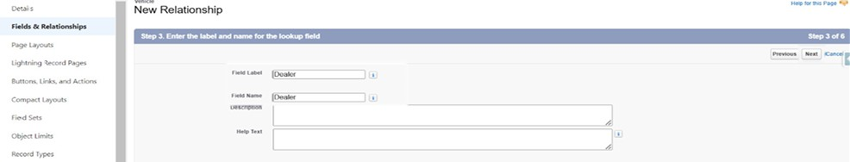
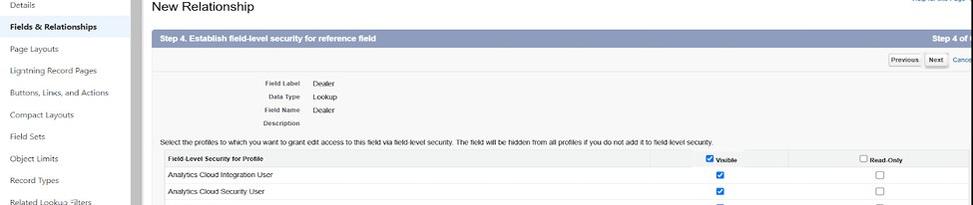
- Click Next and Save.

More Fields Creation

Create remaining fields as mentioned in the Data Management-Fields

Milestone 6: Automation

Flow Creation :

Creating a record triggered flow to assign nearest dealer to the customer’s location
Step 1 : In Quick Find, type Flows and click on Flows. Click New Flow.

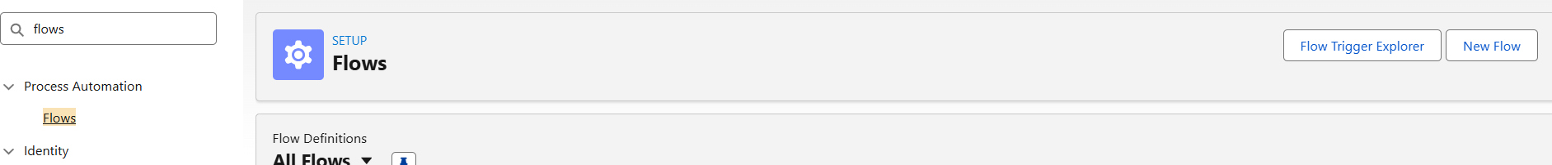
Step 2 : Select Start From Scratch and click Next.
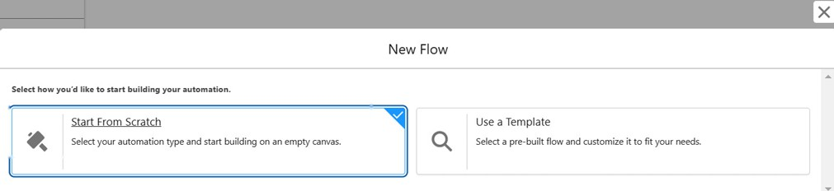

Step 3 : Select Record-Triggered Flow and click Create

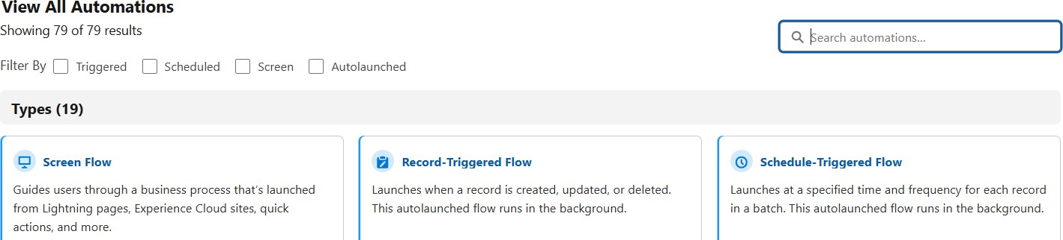
Step 4 : Select Vehicle Order Object
Trigger the Flow When : Select Record is Created.

Set Entry Condition :
All Conditions Are Met (AND) Filed : Status c
Operator : Equals Value : Pending
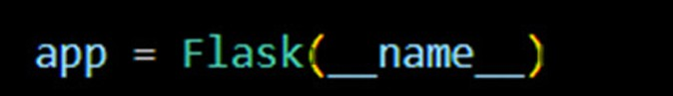
Step 5 : Click + → Select Get Records

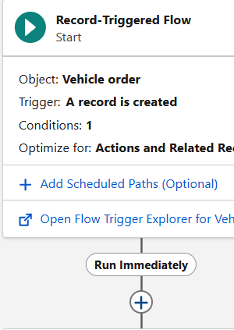
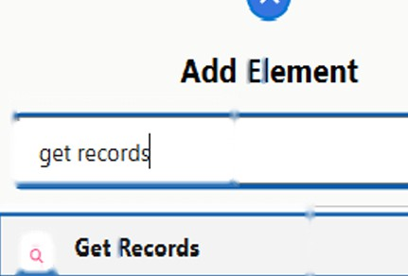 Step 6 :
Label : Get Customer Information
- Object : Vehicle Customer
- Condition :
- Field : Id
- Operator : Equals
- Value : {!$Record.Vehicle_Customer c}

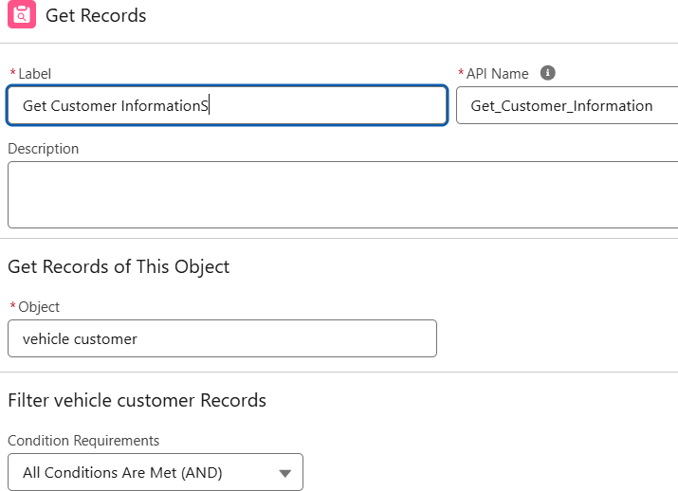

7 : Click + → Select Get Records
- Label : Get Nearest Dealer
- Object : Vehicle Dealer
- Condition :
- Field : Dealer_Location c
- Operator : Equals
- Value : {!Get_Customer_Information.Address c}

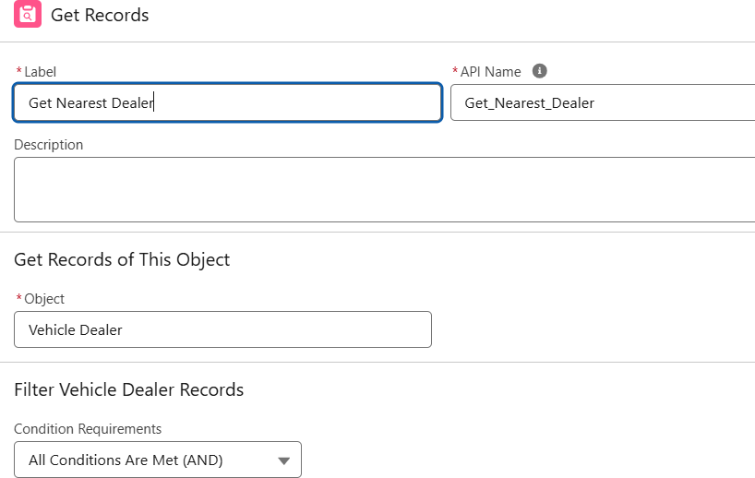

Step 8 : Click + → Select Update Records
- Label : Assign Dealer to Order
- *How to Find Records to Update and Set Their Values : Use the IDs and all field values from a record or record collection
- Select Record(s) to Update : {!Get_Nearest_Dealer}

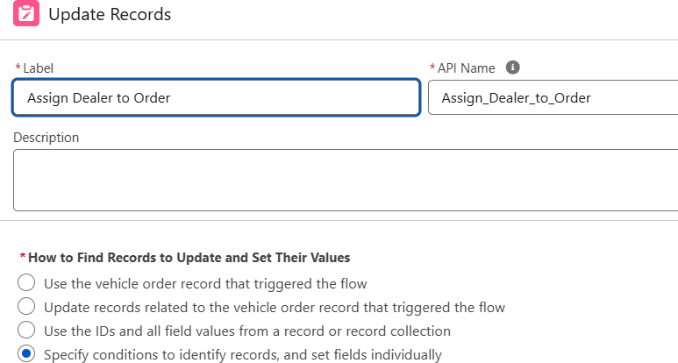

Step 9 : Click Save and Give label Name and Activate Flow.
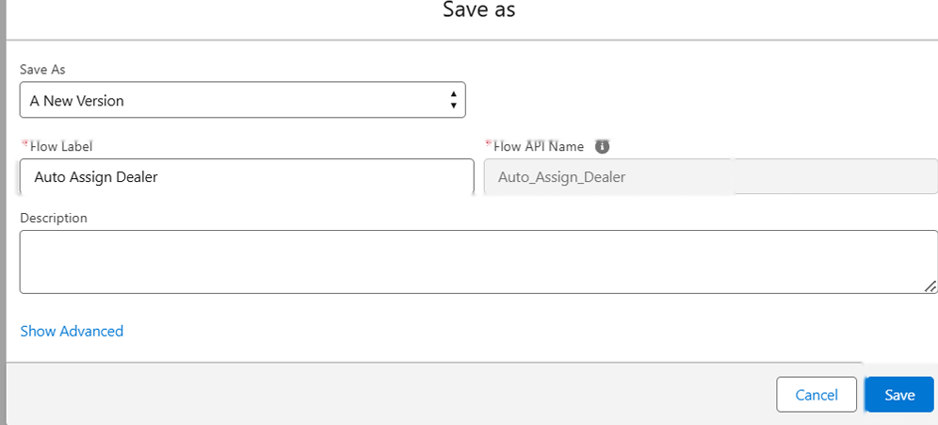
- Label Name : Auto Assign Dealer
Step 10 : Activate Flow

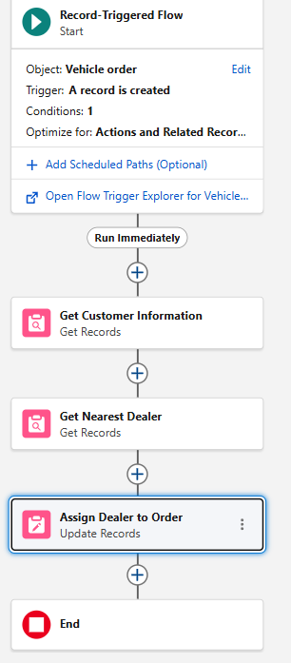
Record-Trigger Flow Creation :

Creating a record triggered flow to send an email to the customer reminding about the test drive.
Step 1 : Select Record-Triggered Flow and click Create

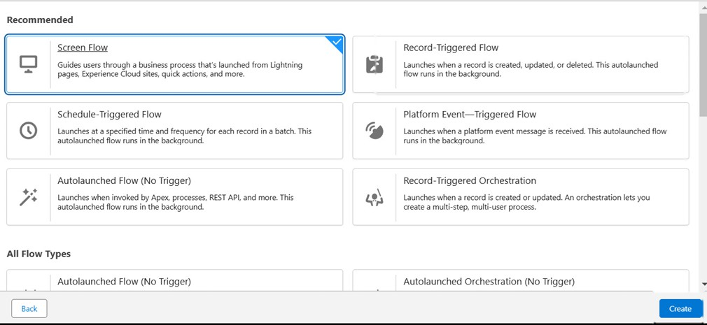
Step 2 : Select Vehicle Test Drive Object
Trigger the Flow When : A record is created or updated

Set Entry Condition :
- All Conditions Are Met (AND)
- Filed : Status c
- Operator : Equals
- Value : Scheduled

Step 3 : Click + Add Scheduled Paths (below the trigger).
- Label: Reminder Before Test Drive.
- Time Source: Test_Drive_Date c
- Offset Number: 1.
- Offset Options: Days Before.
- Click Done.

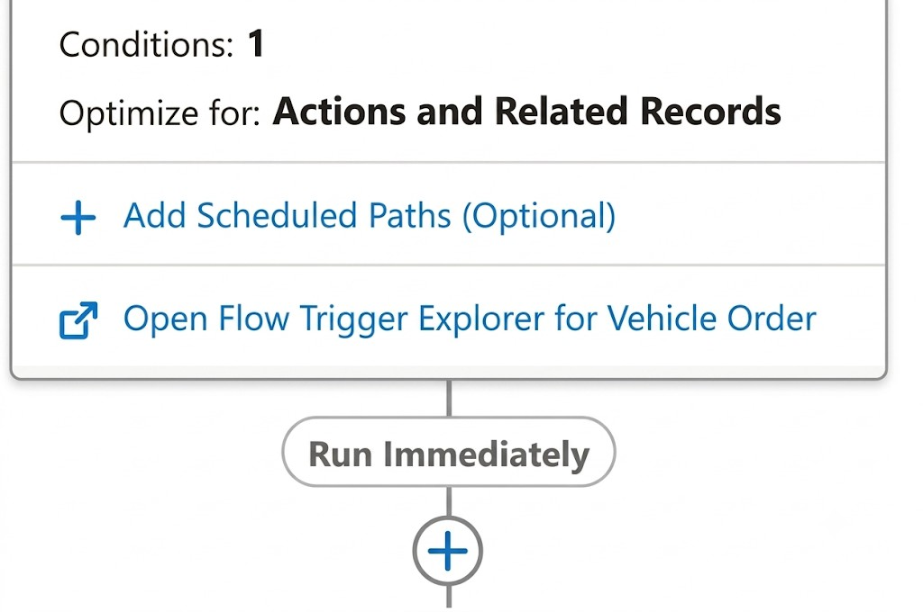
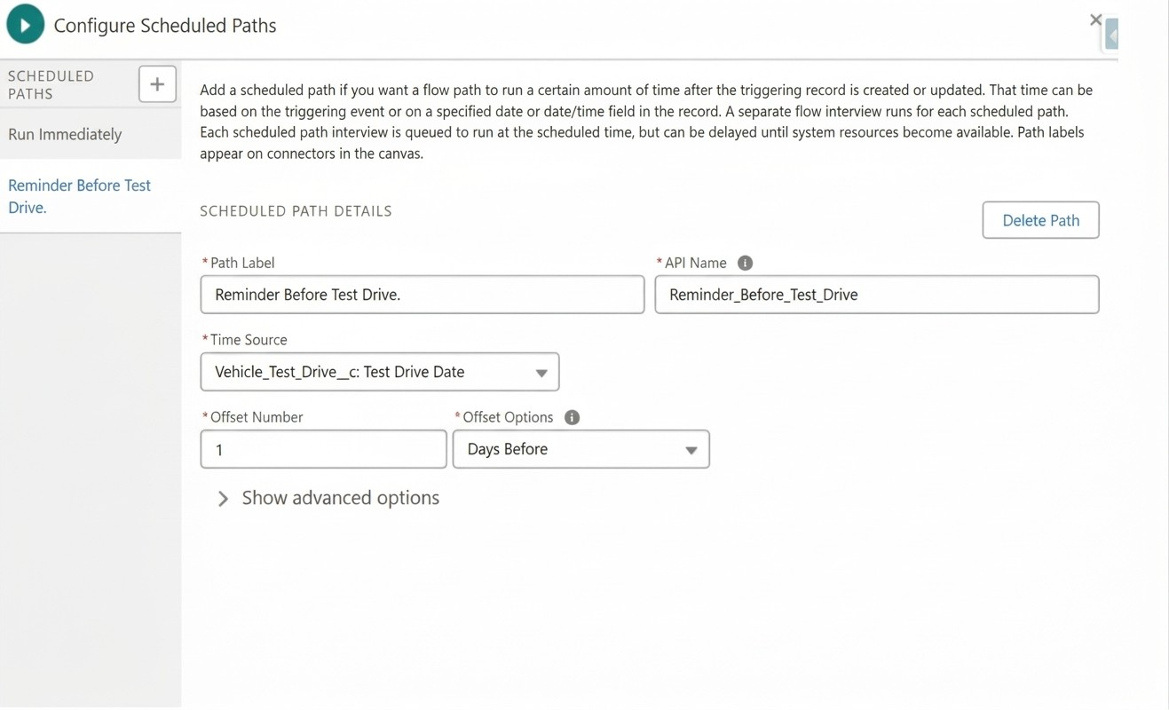
Step 4 :
- Click + Add Element → Get Records.
- Label: Get Customer Information.
- Object: Vehicle_Customer c.
- Filter Conditions: Id = {!$Record.Customer c}.
- How Many Records to Store: Select Only the first record.
- How to Store Record Data: Choose Automatically store all fields.

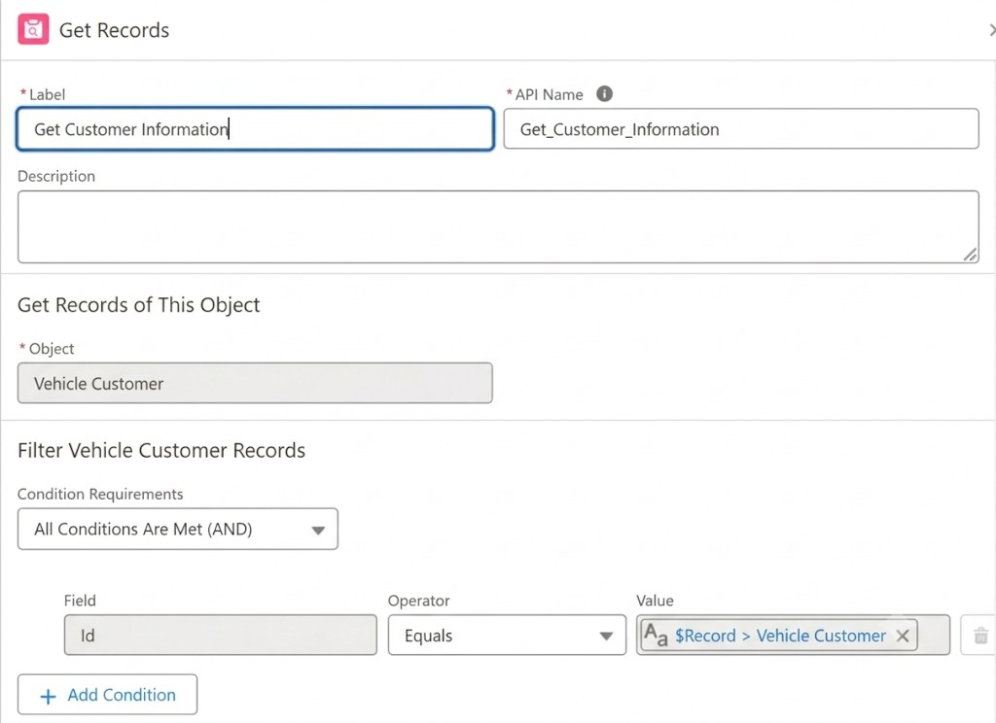
Step 5: Send Reminder Email
- Click + Add Element → Action.
- Action Type: Send Email
- Label: Send Test Drive Reminder.
- Subject: "Reminder: Your Test Drive is Tomorrow!".
- Recipient Address List : {!Get_Customer_Information.Email c}
- Rich-Text-Formatted Body : True

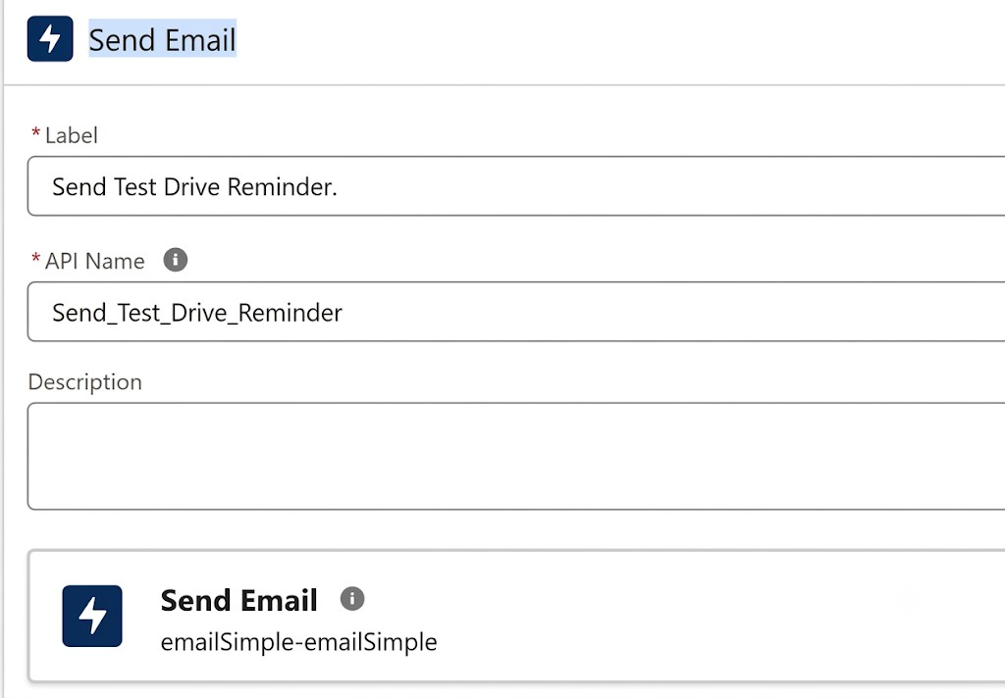
- Body : Create Variable 8 . Api Name : EmailSent
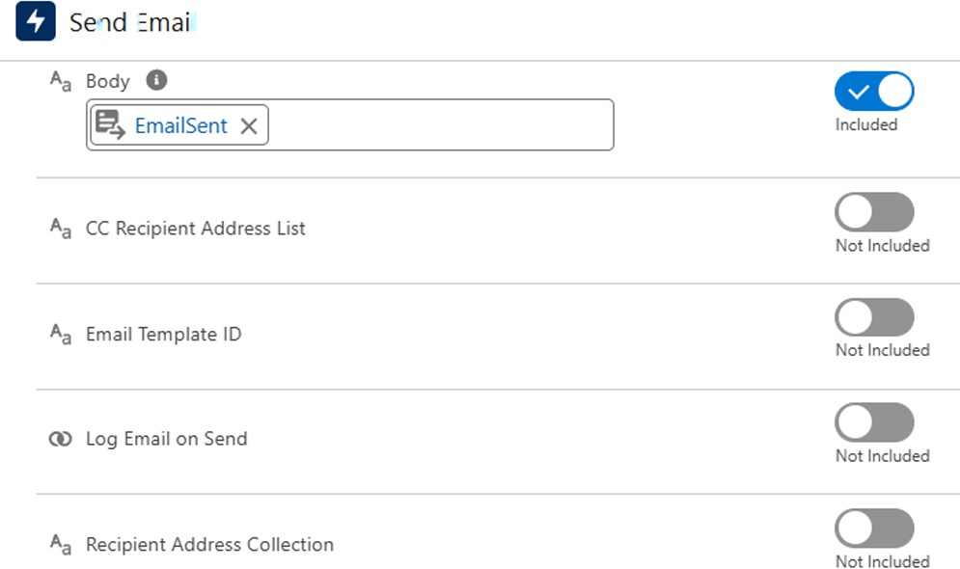
Step 6 : Click save
  - Label Name : Test Drive Reminder

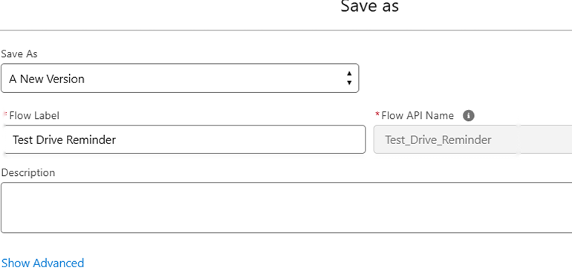
Step 7 :
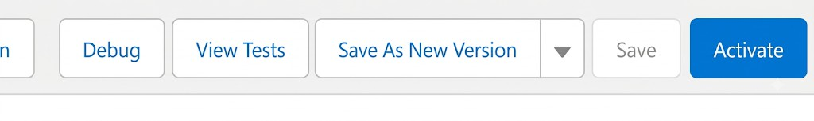
Activate Flow

Flow Page After Creation :
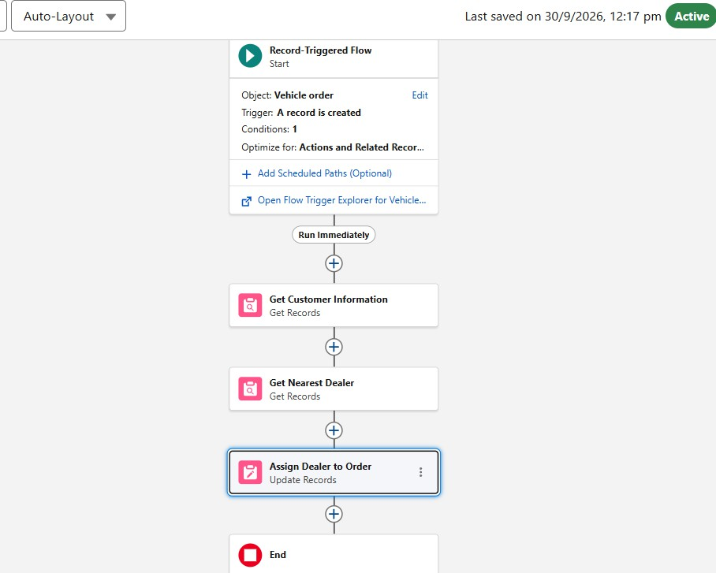

Test your Flow :

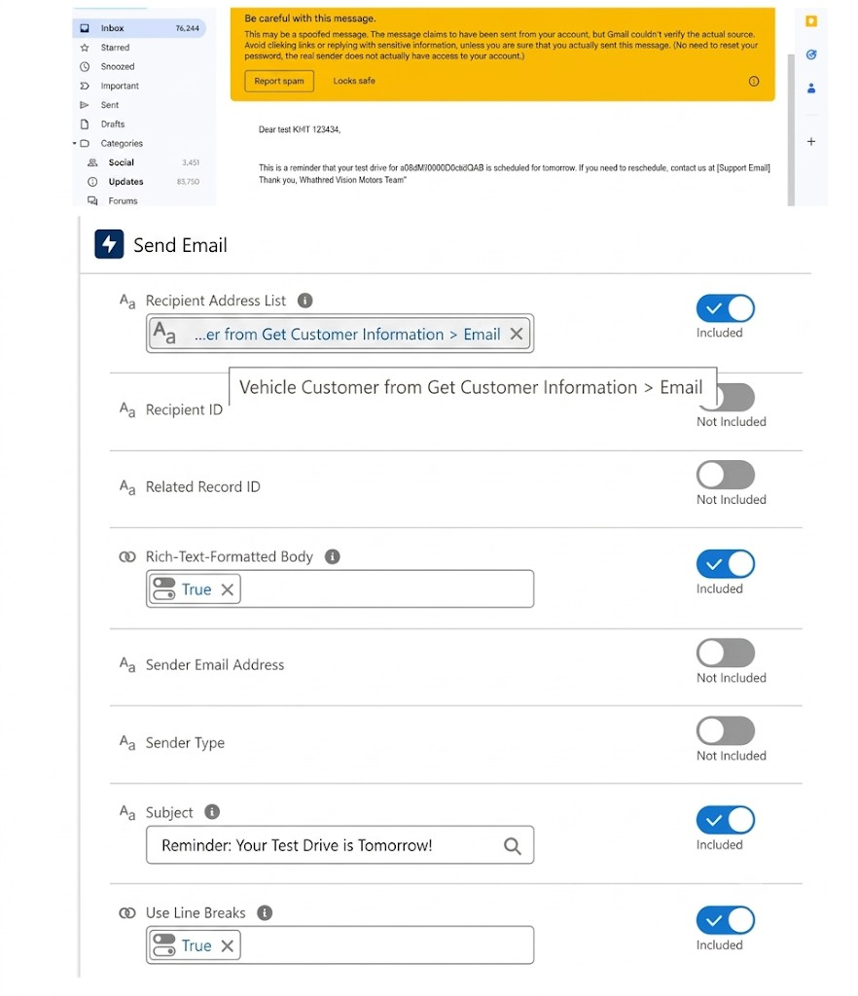

Milestone 7: Apex and Batch Class

Create Apex and Trigger Batch Jobs :
Step 1 : Click Developer Console From Gear icon

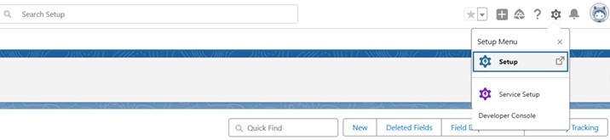
Step 2 : click File then Select New then Select Apex.
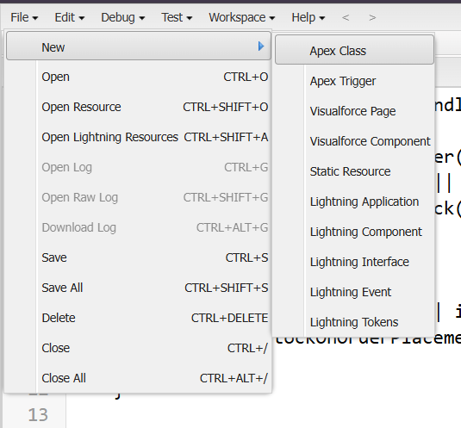 Step 3 : Give Name For Apex Class
- Class Name : VehicleOrderTriggerhandler

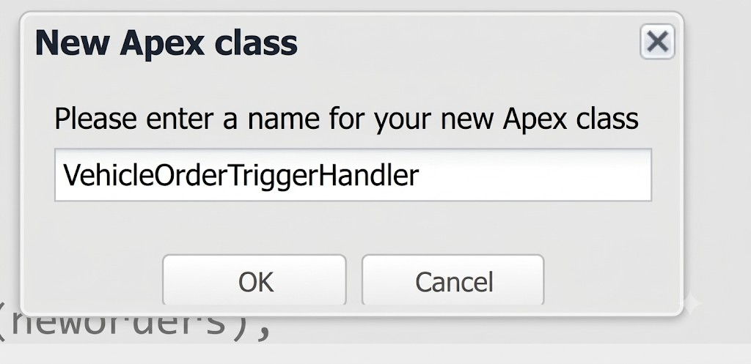
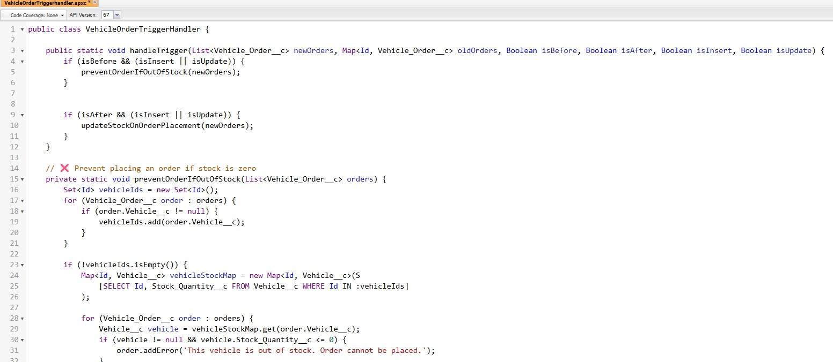
Step 4 : Write Apex Code

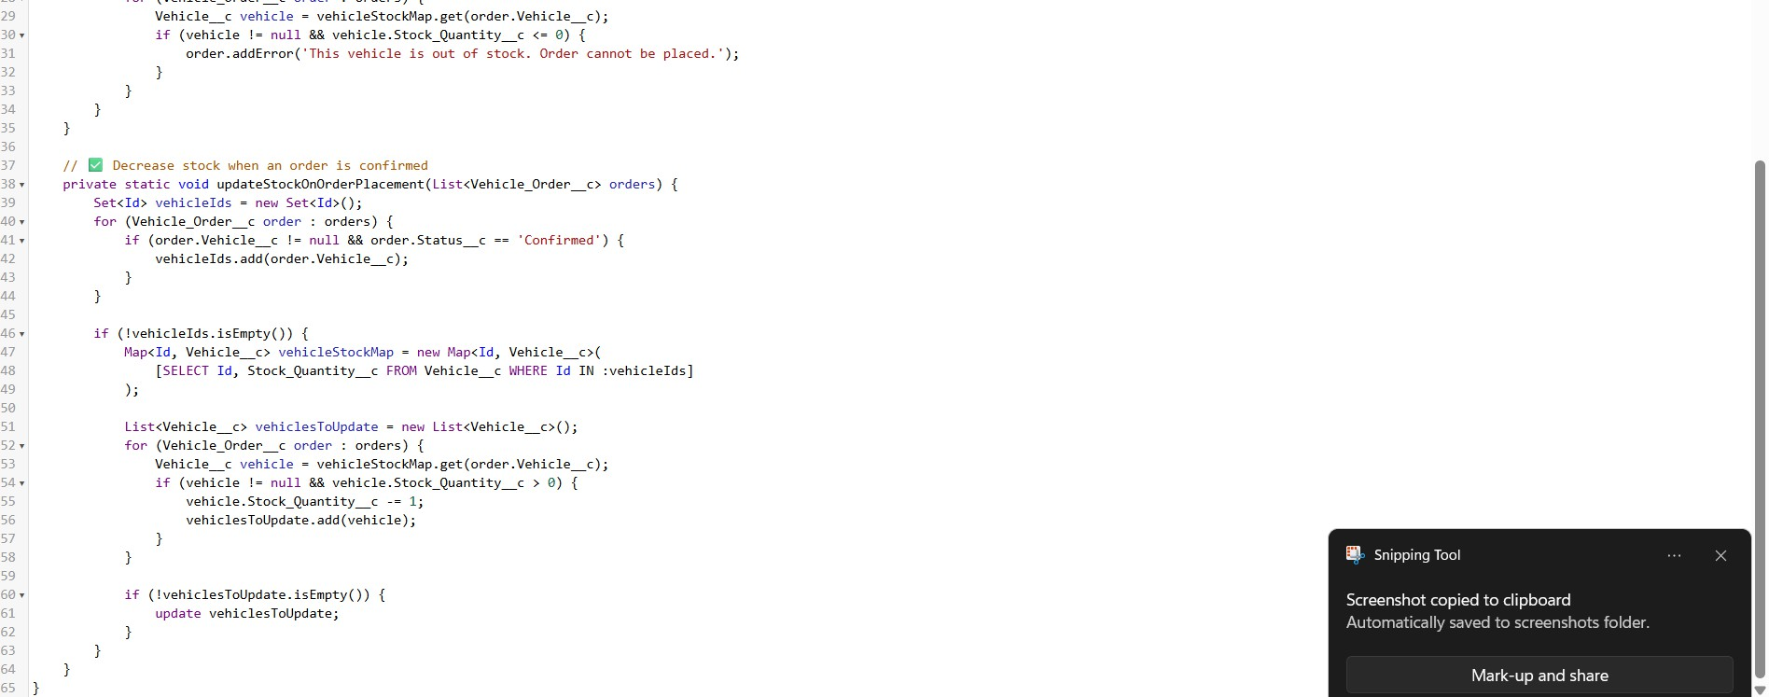

Source Code :

public class VehicleOrderTriggerHandler {
public static void handleTrigger(List<Vehicle_Order c> newOrders, Map<Id, Vehicle_Order c> oldOrders, Boolean isBefore, Boolean isAfter, Boolean isInsert, Boolean isUpdate) {
if (isBefore) {
if (isInsert || isUpdate) { preventOrderIfOutOfStock(newOrders);
}
}

if (isAfter) {
if (isInsert || isUpdate) { updateStockOnOrderPlacement(newOrders);
}
}

}
// Method to prevent orders when the vehicle is out of stock
private static void preventOrderIfOutOfStock(List<Vehicle_Order c> orders) { Set<Id> vehicleIds = new Set<Id>();
for (Vehicle_Order c order : orders) { if (order.Vehicle c != null) {
vehicleIds.add(order.Vehicle c);
}
}
if (!vehicleIds.isEmpty()) {
Map<Id, Vehicle c> vehicleStockMap = new Map<Id, Vehicle c>();
for (Vehicle c vehicle : [SELECT Id, Stock_Quantity c FROM Vehicle c WHERE Id IN :vehicleIds]) {
vehicleStockMap.put(vehicle.Id, vehicle);
}
for (Vehicle_Order c order : orders) {
if (vehicleStockMap.containsKey(order.Vehicle c)) {
Vehicle c vehicle = vehicleStockMap.get(order.Vehicle c); if (vehicle.Stock_Quantity c <= 0) {
order.addError('This vehicle is out of stock. Order cannot be placed.');
}

}
}
}
}

// Method to update vehicle stock when an order is placed
private static void updateStockOnOrderPlacement(List<Vehicle_Order c> orders) { Set<Id> vehicleIds = new Set<Id>();
for (Vehicle_Order c order : orders) {
if (order.Vehicle c != null && order.Status c == 'Confirmed') { vehicleIds.add(order.Vehicle c);
}
}
if (!vehicleIds.isEmpty()) {
Map<Id, Vehicle c> vehicleStockMap = new Map<Id, Vehicle c>();
for (Vehicle c vehicle : [SELECT Id, Stock_Quantity c FROM Vehicle c WHERE Id IN :vehicleIds]) {
vehicleStockMap.put(vehicle.Id, vehicle);
}
List<Vehicle c> vehiclesToUpdate = new List<Vehicle c>(); for (Vehicle_Order c order : orders) {
if (vehicleStockMap.containsKey(order.Vehicle c)) {
Vehicle c vehicle = vehicleStockMap.get(order.Vehicle c); if (vehicle.Stock_Quantity c > 0) {
vehicle.Stock_Quantity c -= 1; vehiclesToUpdate.add(vehicle);
}
}
}
if (!vehiclesToUpdate.isEmpty()) {

update vehiclesToUpdate;
}
}
}
}
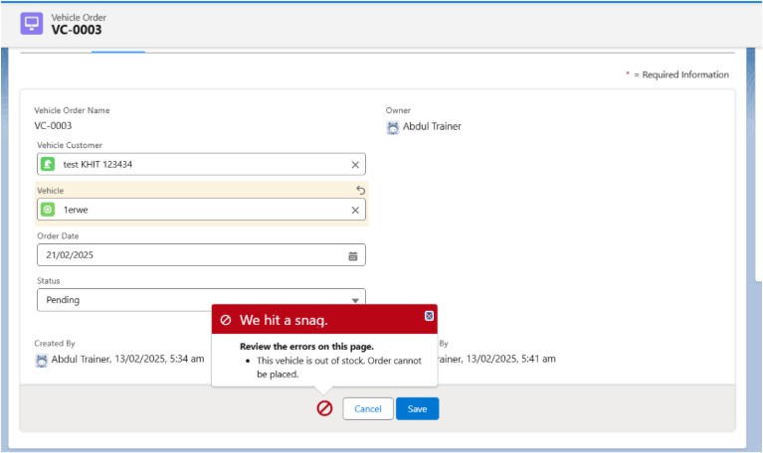
Step 5 : Write Trigger Handler

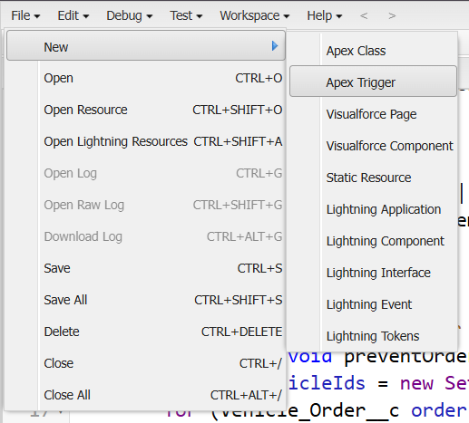
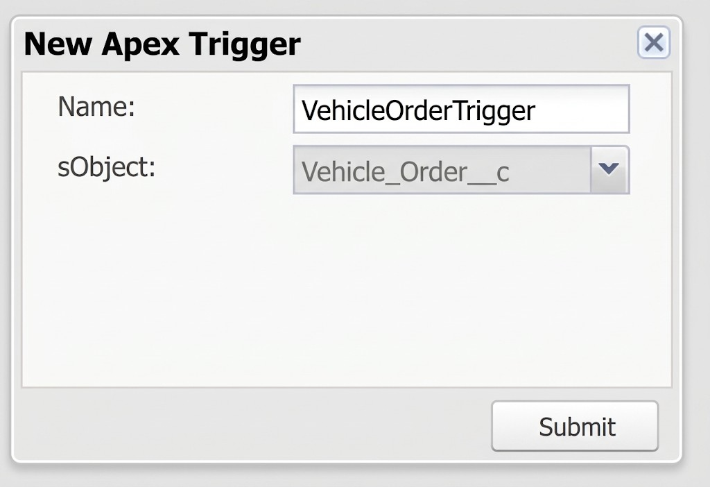
Step 6 : Writer Trigger Class Name and Select Vehicle Order Object
Step 7 : Call Apex Class in Trigger Class Source Code:

trigger VehicleOrderTrigger on Vehicle_Order c (before insert,before update, after insert, after update) {
VehicleOrderTriggerHandler.handleTrigger(Trigger.new, Trigger.oldMap, Trigger.isBefore,Trigger.isAfter, Trigger.isInsert, Trigger.isUpdate);
}

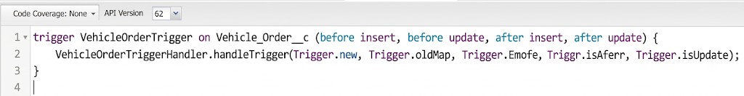
Step 8 : Create Batch Job
A customer places an order, but the vehicle is out of stock.
- The order remains pending.
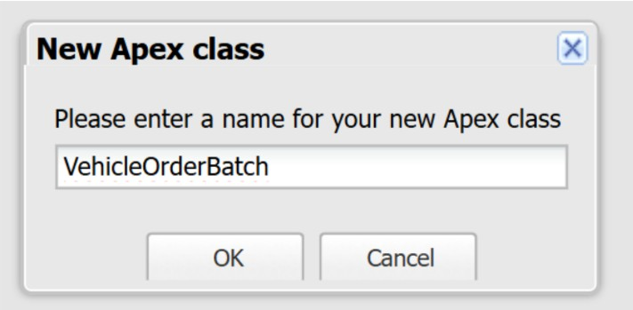
- After new stock is added, the batch job updates the order to confirmed.

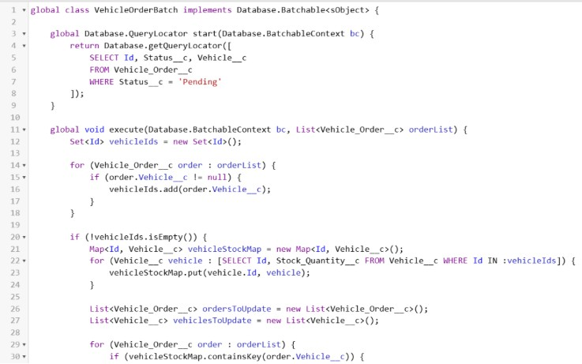

Source Code:
global class VehicleOrderBatch implements Database.Batchable<sObject> { global Database.QueryLocator start (Database.BatchableContext bc) { return Database.getQueryLocator([
SELECT Id, Status_c, Vehicle c
FROM Vehicle_Order c
WHERE Status c 'Pending'
]);
}
global void execute(Database.BatchableContext bc, List<Vehicle_Order_c> orderList) { Set<Id> vehicleIds = new Set<Id>();
for (Vehicle_Order_c order orderList) {

if (order.Vehicle_c != null) { vehicleIds.add(order.Vehicle c);
}
}
if (!vehicleIds.isEmpty()) {
Map<Id, Vehicle c> vehicleStockMap = new Map<Id, Vehicle c>();
for (Vehicle_c vehicle: [SELECT Id, Stock Quantity_c FROM Vehicle_c WHERE Id IN vehicleIds]) {
vehicleStockMap.put(vehicle. Id, vehicle);
}
List<Vehicle_Order_c> ordersToUpdate = new List<Vehicle_Order_c>(); List<Vehicle c> vehiclesToUpdate = new List<Vehicle c>();
for (Vehicle_Order_c order orderList) {
if (vehicleStockMap.containsKey(order. Vehicle c)) { Vehicle_c vehicle = vehicleStockMap.get(order. Vehicle c); if (vehicle.Stock_Quantity c > 0) {
order.Status c = 'Confirmed'; vehicle.Stock_Quantity c -= 1;
ordersToUpdate.add(order); vehiclesToUpdate.add(vehicle);
}
}
}
if (!ordersToUpdate.isEmpty()) { update ordersToUpdate;

}
if (!vehicles ToUpdate.isEmpty()) { update vehiclesToUpdate;
}
}
global void finish(Database.BatchableContext bc) { System.debug('Vehicle order batch job completed.');
}
}
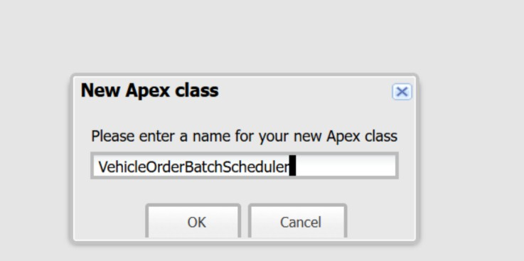
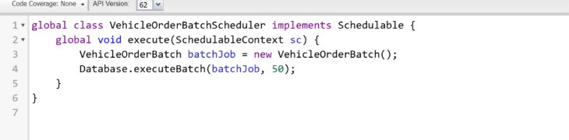
Step 9 : Create Schedule Class then revoked Batch Class in Schedule Class

Source Code :

global class VehicleOrderBatchScheduler implements Schedulable { global void execute(SchedulableContext sc) {
VehicleOrderBatch batchJob = new VehicleOrderBatch(); Database.executeBatch(batchJob, 50); // 50 is the batch size
}
}
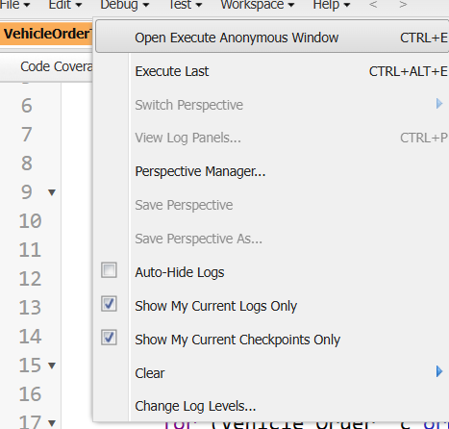
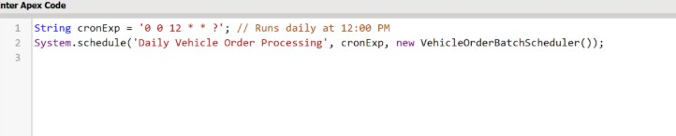
Step 10 : Schedule the Batch Job To run the batch job every night at midnight :

Source Code :
String cronExp = '0 0 12 * * ?'; // Runs daily at 12:00 PM System.schedule('Daily Vehicle Order Processing', cronExp, new VehicleOrderBatchScheduler());
Step 11 : You Can Check where this Schedule Job is Running

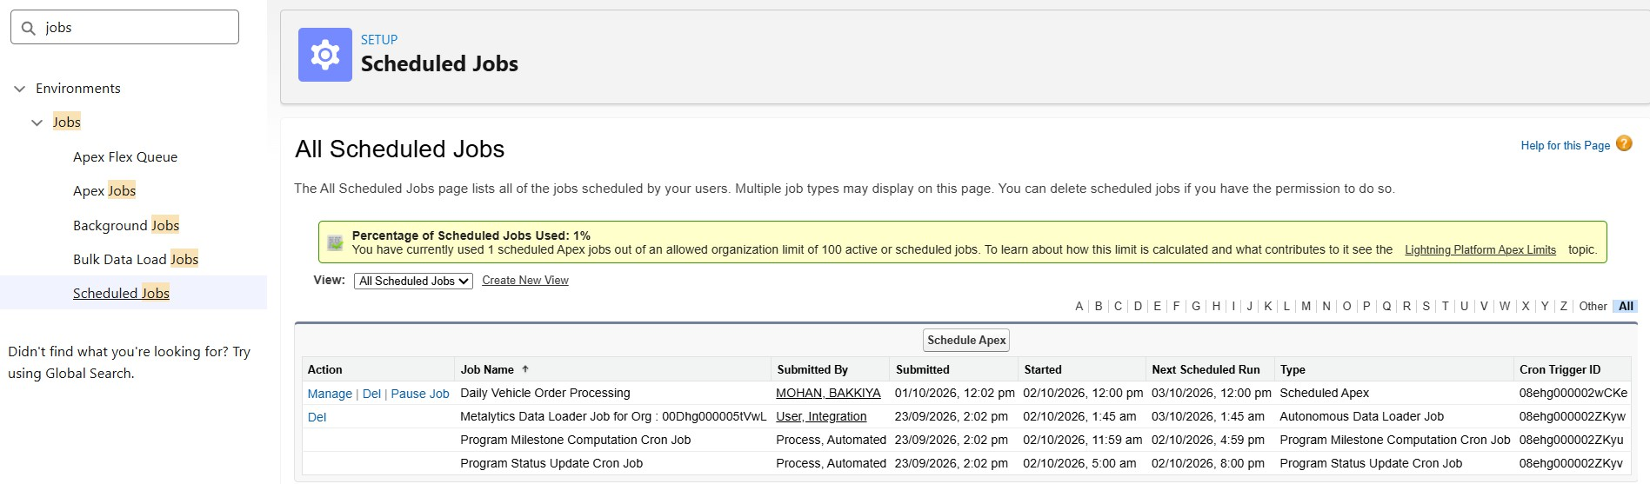

FUNCTIONAL & PERFORMANCE TESTING

During testing, screenshots were captured from Salesforce to validate vehicle creation, dealer assignment, stock validation triggers, order status updates, batch processing, scheduled reminders, and dashboard analytics. All features were verified to ensure correct functionality and performance.

ADVANTAGES & DISADVANTAGES

Advantages

  - Centralized data
  - Automated workflows
  - Real-time reporting

Disadvantages
  - Salesforce dependency
  - Requires initial configuration effort

Conclusion:

The Salesforce CRM implementation at WhatNext Vision Motors successfully modernizes vehicle ordering and dealership management. Automation improves efficiency, accuracy, and customer experience.

FUTURE SCOPE
  - Mobile ordering app
  - Dealer GPS integration
  - SMS notifications
  - AI-based demand forecasting

APPENDIX
  - Source Code: Salesforce Configuration
  - Dataset: Salesforce Objects
  - GitHub / Demo: Salesforce Developer Org

Thank You

